Name:

Screenshot showing added columns

Activity 1: Looking at the screenshot below, add additional columns to your saved version of The Shakes tour spreadsheet to add VAT.

Activity 2: Add the VAT rate of 17.5% to your spreadsheet as shown.

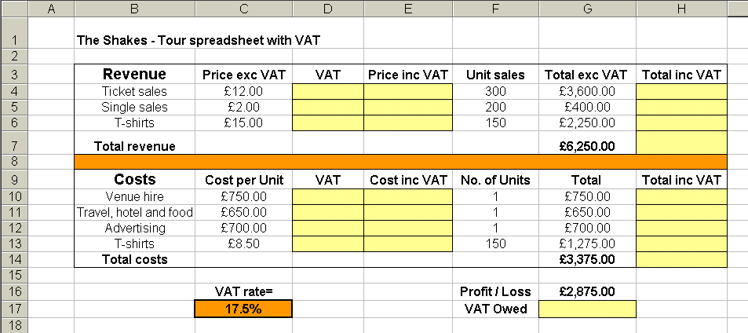
Activity 3: Format the spreadsheet to outline and colour the cells in which you are going to enter formulae.

